Aleander Baldree
2/25/26
Module 9.3 Assignment
CSD340

GitHub Link:
https://github.com/Panda-Alex21687/CSD340

9.3 Assignment with JavaScript inserts:
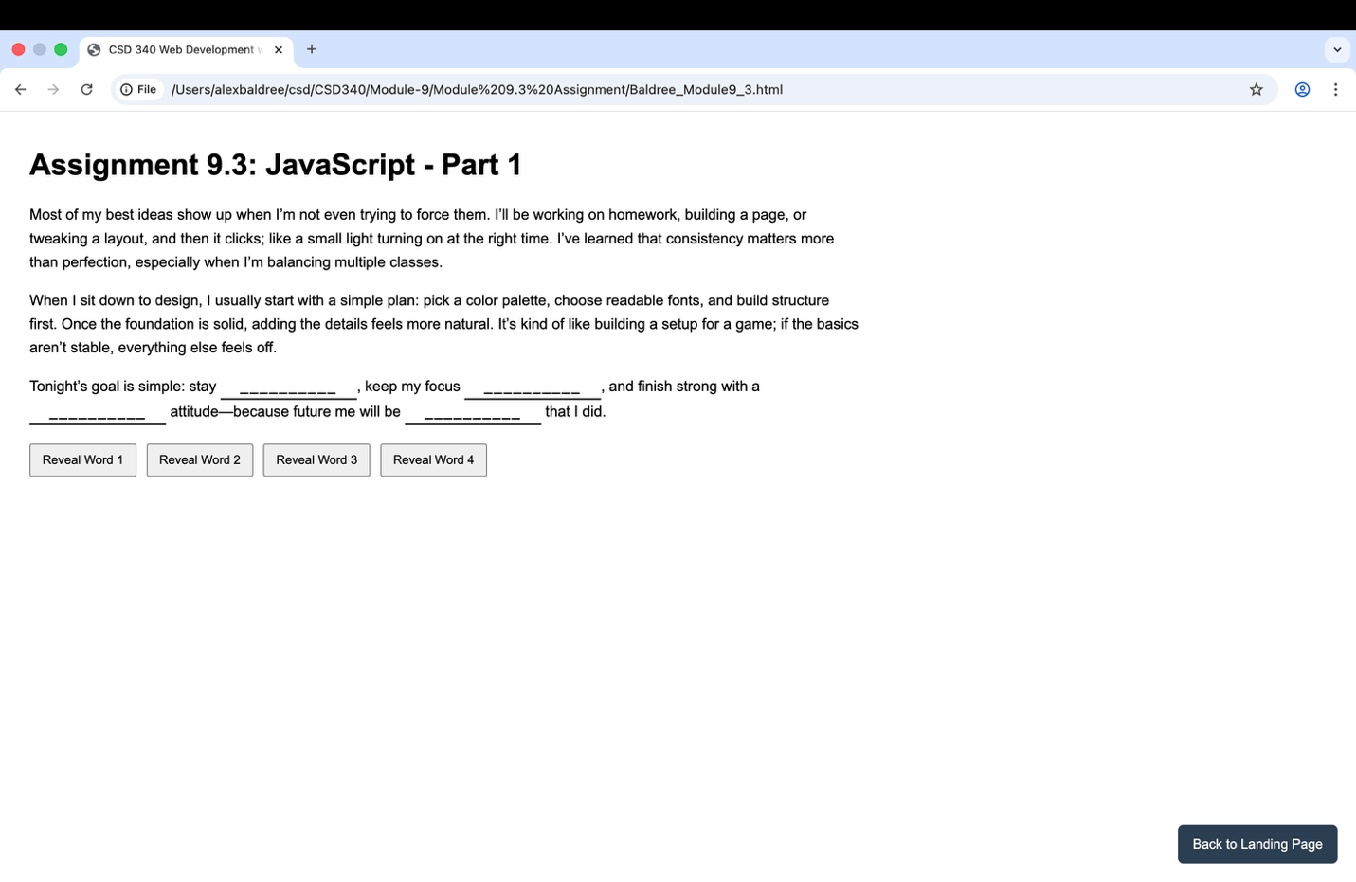

9.3 Assignment with inserts used:
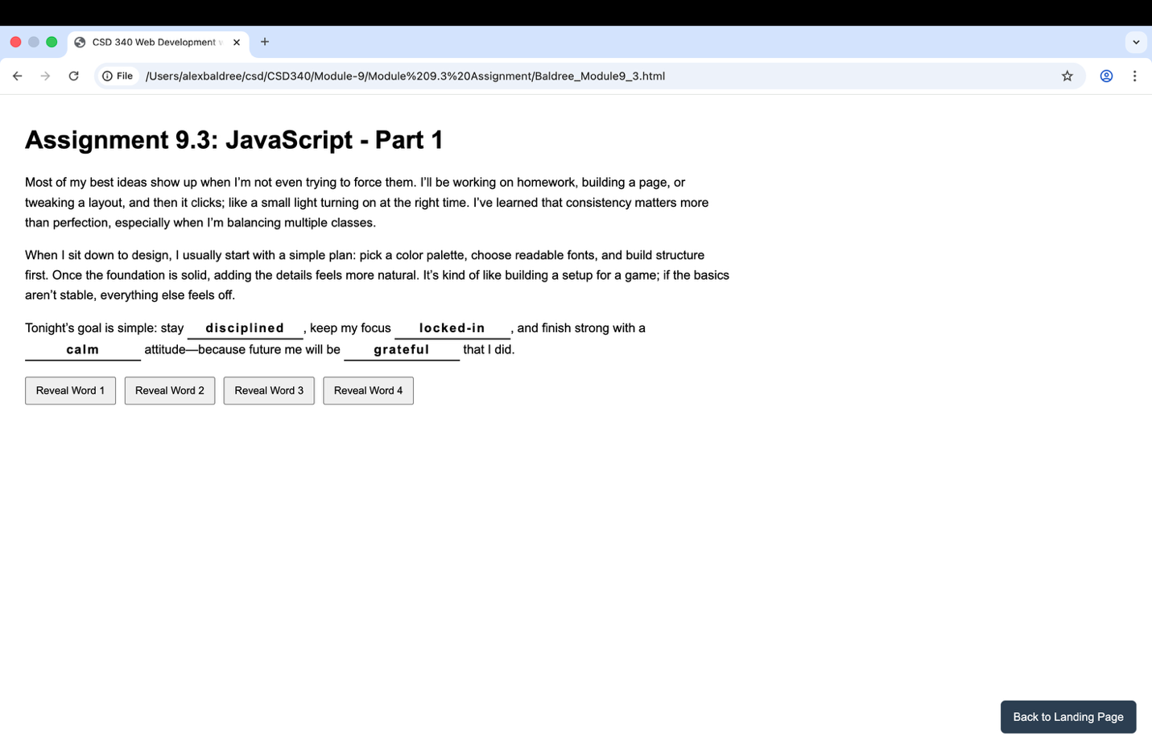

Back to landing page works:
